**Class Level Unit Testing**

<ScoreCounter>

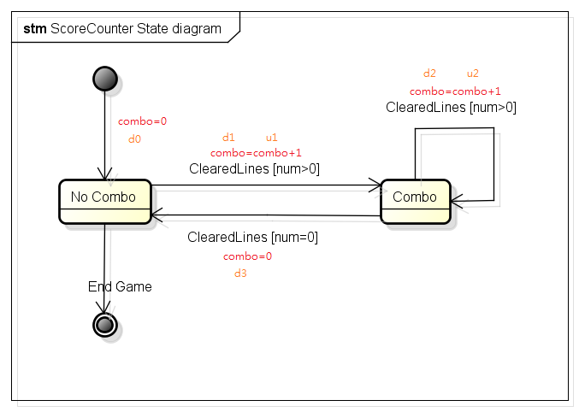

|  |  |
| --- | --- |
| Pair | Path |
| (d0,u1) | v |
| (d1,u2) | v |
| (d2,u2) | v |
| (d3,u1) | v |

Path : No-combo→Combo→Combo→Combo→No-Combo

<Board>

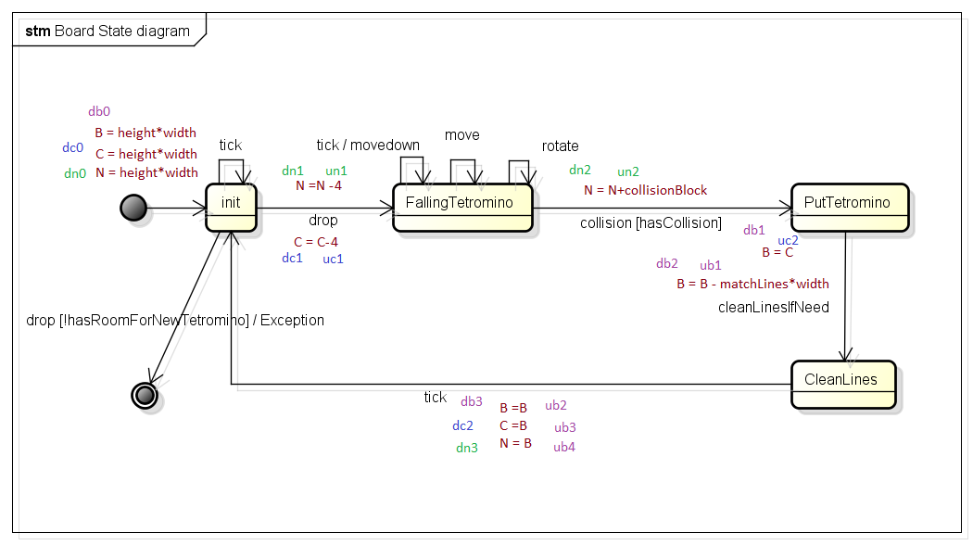

|  |  |
| --- | --- |
| Pair | Path |
| (db1,ub1) | v |
| (db2,ub2) | v |
| (db3,ub3) | v |
| (db3,ub4) | v |
| (dc0,uc1) | v |
| (dc1,uc2) | v |
| (dn0,un1) | v |
| (dn1,un2) | v |

B: Path : init→FallingTetromino→PutTetromino→CleanLines→init

C: Path : init→FallingTetromino→PutTetromino→CleanLines→init

N: Path : init→FallingTetromino→PutTetromino→CleanLines→init

<GameController>

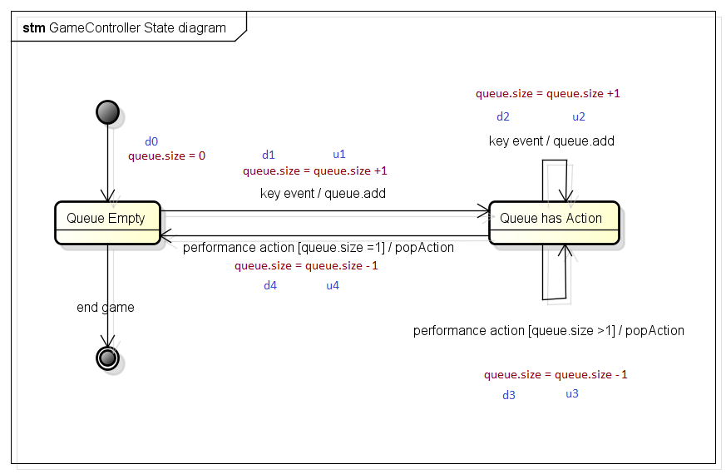

|  |  |
| --- | --- |
| Pair | Path |
| (d0,u1) | v |
| (d1,u2) | v |
| (d1,u4) | v |
| (d2,u3) | v |
| (d3,u2) | v |
| (d3,u4) | v |
| (d4,u1) | v |

Path : Empty →a has Action →a has Action →d has Action →a has Action →d has Action

→d Empty →a has Action →d Empty